AWS EKS – Sample Application Deployment with Nginx WebServer:

Create a CLI User – with the Following Policies:

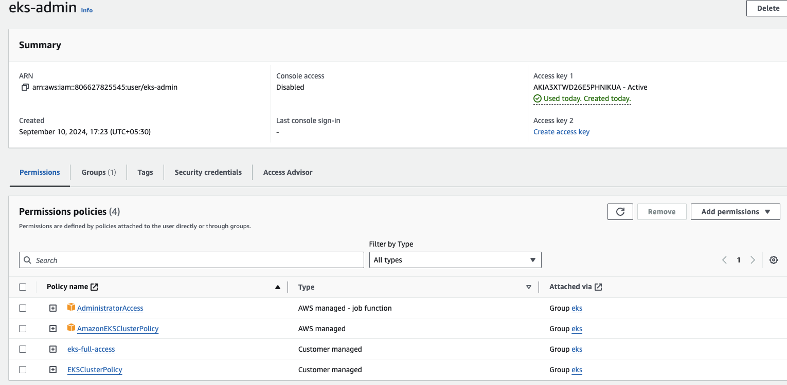

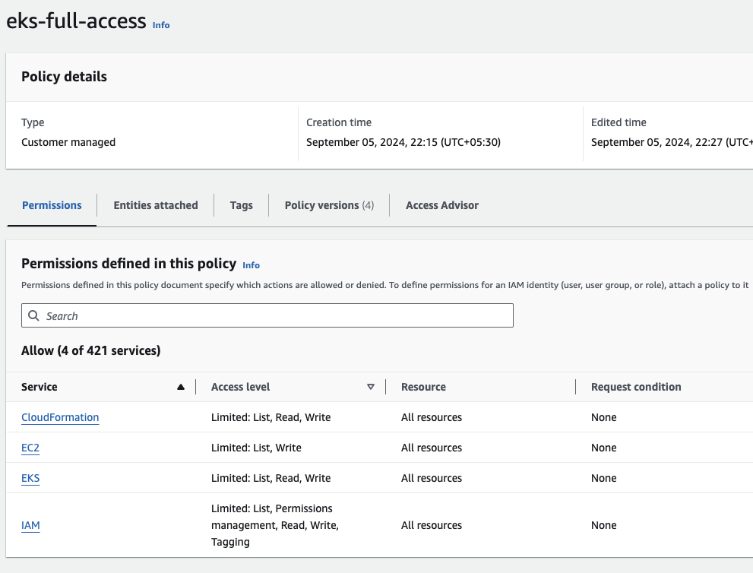

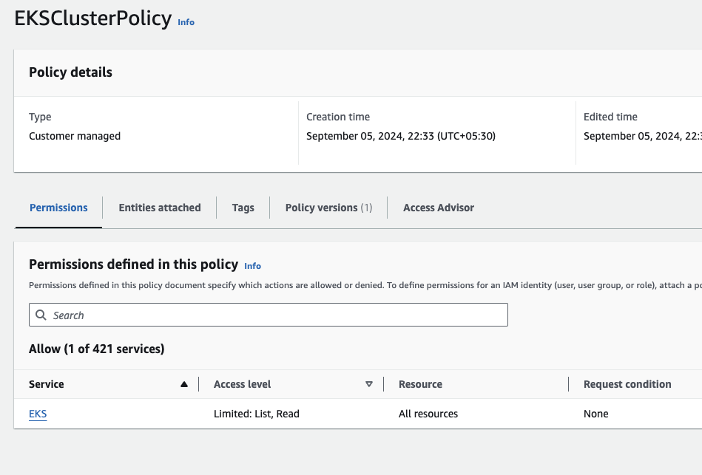

>> aws configure
>> access key
>> secret key
>> region
>> json

Install EKSCTL

eksctl create cluster --name my-cluster --region us-east-1 --nodes 3 --node-type t3.medium\n

eksctl get nodes

kubectl get nodes

There is a Differnece between
EKSCTL and kubectl

Step 1: Create a Deployment
Deployments to create new ReplicaSets, or to remove existing Deployments and adopt all their resources with new Deployments.
- vim deployment.yaml

apiVersion: apps/v1
kind: Deployment
metadata:
name: hello-world
labels:
app: hello-world
spec:
replicas: 1
selector:
matchLabels:
app: hello-world
template:
metadata:
labels:
app: hello-world
spec:
containers:
- name: hello-world-pod
image: nginx:latest
ports:
- containerPort: 80
- After execute commnd below output:
[root@ip-172-31-17-53 ~]# kubectl apply -f deployment.yaml
deployment.apps/hello-world created
[root@ip-172-31-17-53 ~]# kubectl get po -A
NAMESPACE NAME READY STATUS RESTARTS AGE
default hello-world-79cff76897-7ffcj 1/1 Running 0 7s
kube-system aws-node-gsv85 1/1 Running 0 3m40s
kube-system aws-node-qphwl 1/1 Running 0 3m35s
kube-system coredns-7975d6fb9b-kh6jk 1/1 Running 0 10m
kube-system coredns-7975d6fb9b-nx67r 1/1 Running 0 10m
kube-system kube-proxy-lf7vc 1/1 Running 0 3m35s
kube-system kube-proxy-m4dqc 1/1 Running 0 3m40s
Step 2: Create a service
Service is a method for exposing a network application that is running as one or more Pods in your cluster.
Each Pod gets its own IP address (Kubernetes expects network plugins to ensure this). For a given Deployment in your cluster, the set of Pods running in one moment in time could be different from the set of Pods running that application a moment later.
1
2
3
4
[root@ip-172-31-17-53 ~]# kubectl get svc -A
NAMESPACE NAME TYPE CLUSTER-IP EXTERNAL-IP PORT(S) AGE
default kubernetes ClusterIP 10.100.0.1 <none> 443/TCP 11m
kube-system kube-dns ClusterIP 10.100.0.10 <none> 53/UDP,53/TCP 10m
The Service API, part of Kubernetes, is an abstraction to help you expose groups of Pods over a network. Each Service object defines a logical set of endpoints (usually these endpoints are Pods) along with a policy about how to make those pods accessible.
- vim service.yaml
apiVersion: v1
kind: Service
metadata:
name: hello-world-service
spec:
selector:
app: hello-world
ports:
- name: http
protocol: TCP
port: 80
targetPort: 80
type: LoadBalancer
After execute commnd below output:
1
2
3
4
5
[root@ip-172-31-17-53 ~]# kubectl get svc -A
NAMESPACE NAME TYPE CLUSTER-IP EXTERNAL-IP PORT(S) AGE
default hello-world-service LoadBalancer 10.100.238.91 aee3f06d0501f4528a7b0bad2fa2f85f-625499864.us-east-1.elb.amazonaws.com 80:30616/TCP 4s
default kubernetes ClusterIP 10.100.0.1 <none> 443/TCP 13m
kube-system kube-dns ClusterIP 10.100.0.10 <none> 53/UDP,53/TCP 13m
Command line Output:
[root@ip-172-31-17-53 ~]# curl aee3f06d0501f4528a7b0bad2fa2f85f-625499864.us-east-1.elb.amazonaws.com
<!DOCTYPE html>
<html>
<head>
<title>Welcome to nginx!</title>
<style>
html { color-scheme: light dark; }
body { width: 35em; margin: 0 auto;
font-family: Tahoma, Verdana, Arial, sans-serif; }
</style>
</head>
<body>
<h1>Welcome to nginx!</h1>
<p>If you see this page, the nginx web server is successfully installed and
working. Further configuration is required.</p>
<p>For online documentation and support please refer to
<a href="http://nginx.org/">nginx.org</a>.<br/>
Commercial support is available at
<a href="http://nginx.com/">nginx.com</a>.</p>
<p><em>Thank you for using nginx.</em></p>
</body>
</html>
Browser Output:
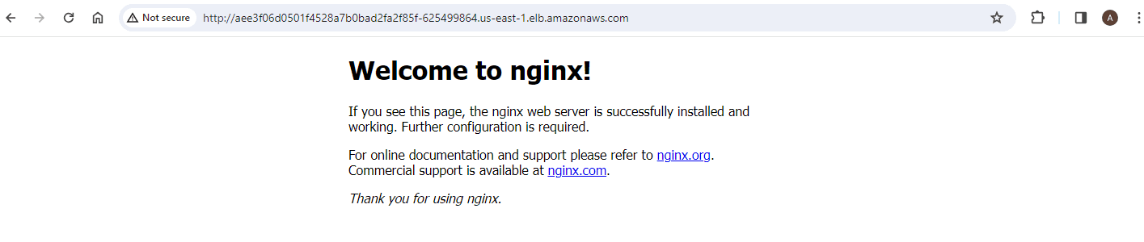
Conclusion :
This solution helps you quickly install simple application and access cluster using the Amazon Elastic Load Balancer

- vim deployment.yaml
apiVersion: apps/v1
kind: Deployment
metadata:
name: hello-world
labels:
app: hello-world
spec:
replicas: 1
selector:
matchLabels:
app: hello-world
template:
metadata:
labels:
app: hello-world
spec:
containers:
- name: hello-world-pod
image: nginx:latest
ports:
- containerPort: 80

Configuration of PODS:

>> kubectl apply -f https://github.com/kubernetes-sigs/metrics-server/releases/latest/download/components.yaml

apiVersion: autoscaling/v1
kind: HorizontalPodAutoscaler
metadata:
name: hello-world-hpa
spec:
scaleTargetRef:
apiVersion: apps/v1
kind: Deployment
name: hello-world
minReplicas: 1
maxReplicas: 10
targetCPUUtilizationPercentage: 50

>> nano hpa-logic.yaml

>> kubectl exec -it hello-world-5b4d4cd95b-td5tt -- dd if=/dev/zero of=/dev/null bs=1M count=1000

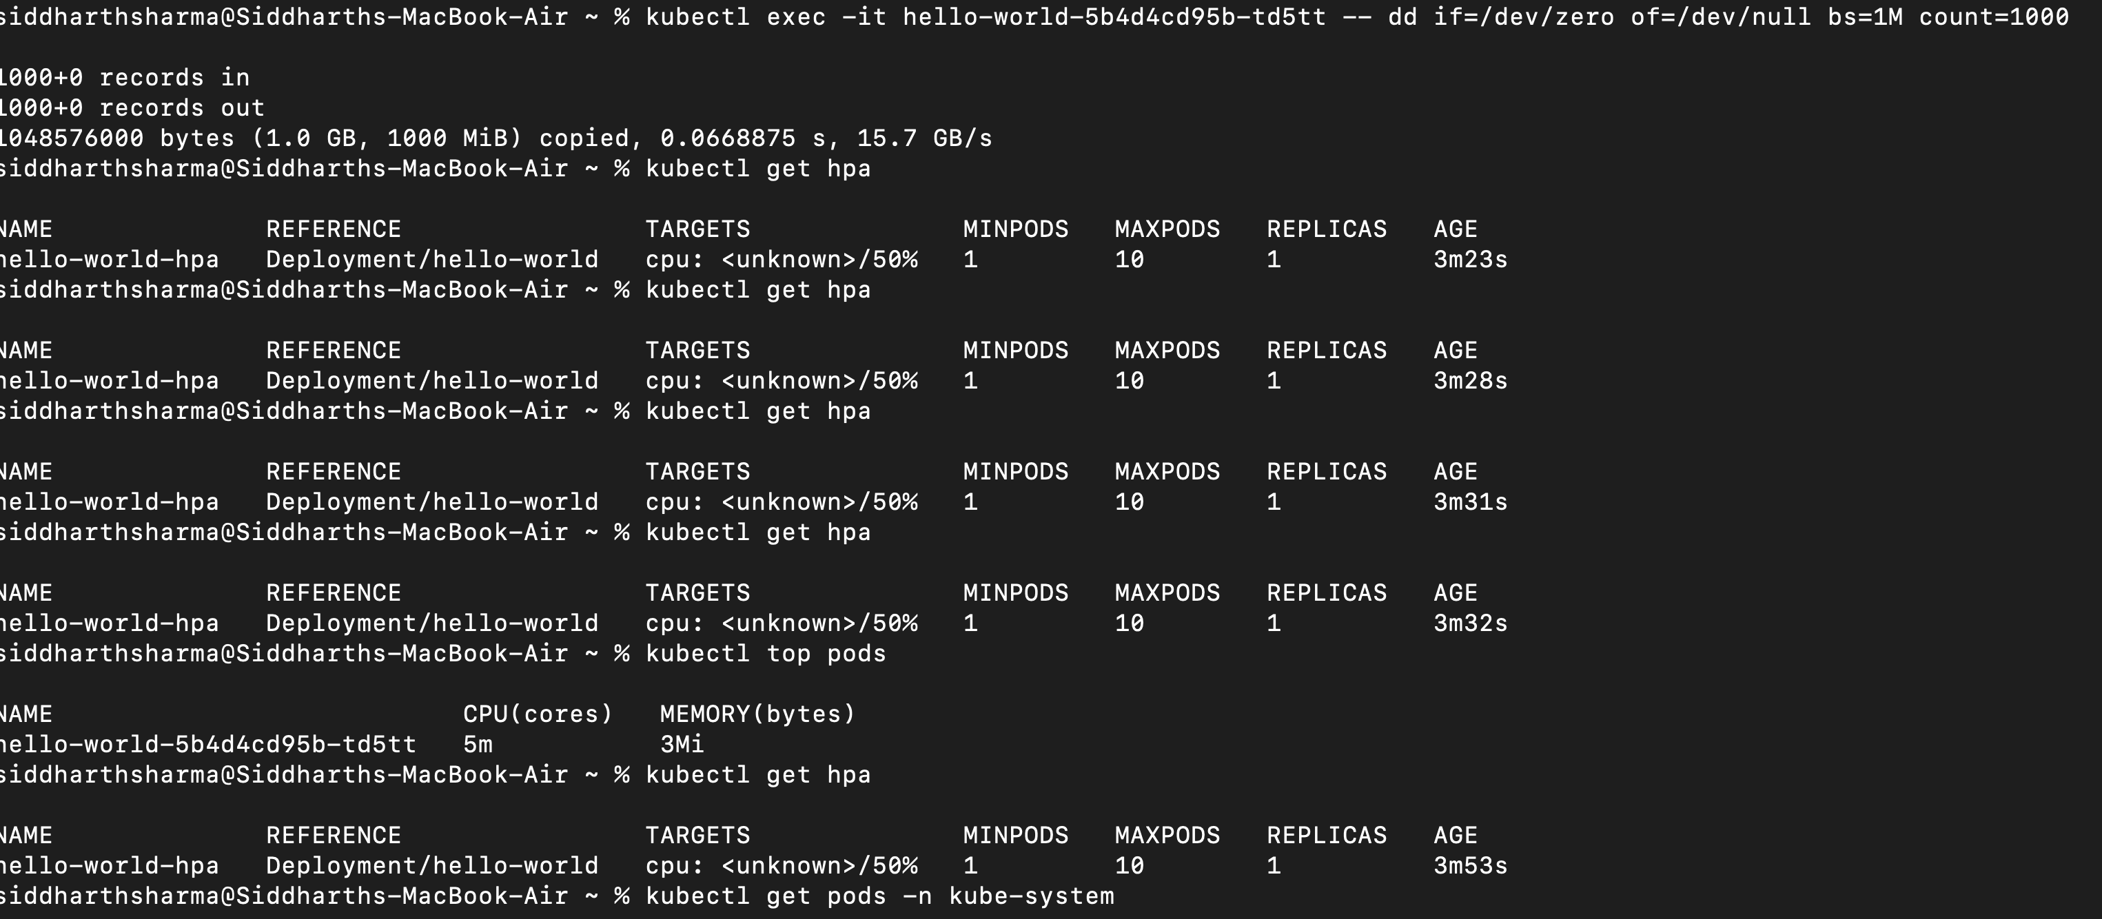

Code Share NOTES:
EKS CTL Lab. - Upgrad

Steps for the Lab:
1) aws login -> IAM
2) Create IAm role / role / permission
3) access key / secret key generation
4) install awscli, eksctl
5) aws configure with Access / Secret Key
6) create - cluster
7) do the task
8) delete the cluster

########################################################################################################################################################################

Create a IAM User -> With Policies as below:
AdministratorAccess, AmazonEKSClusterPolicy

Then Click on User(new) which you just created now -> and click on Security Credentials -> Click on " Create access key "

-> after Clicking on Create Access Key - It will ask for UseCase

-> USE CASE: CLI
-> Ignore the next step
-> Generate the Keys
-> Copy the access key and Secret key before click on finish Button ( as it will not show again after this)

########################################################################################################################################################################

Launching the Ec2 - ubuntu instance

#### installation of AWS CLI #######

https://docs.aws.amazon.com/cli/latest/userguide/getting-started-install.html

sudo apt update

curl "https://awscli.amazonaws.com/awscli-exe-linux-x86_64.zip" -o "awscliv2.zip"

sudo apt install unzip

unzip awscliv2.zip

sudo ./aws/install

aws --version

#### Install eksctl ######

curl --silent --location "https://github.com/weaveworks/eksctl/releases/latest/download/eksctl_$(uname -s)_amd64.tar.gz" | tar xz -C /tmp

sudo mv /tmp/eksctl /usr/local/bin

eksctl version

#######################################################################################################################################################################

>> aws configure with access key and secret key along with region (us-east-1 / mumbai / ap-south-1)

>> aws configure
>> access key
>> secret key
>> region
>> json

########################################################################################################################################################################

commands for creating a cluser and deploying a webserver (nginx Image) and expose with a service loadbalancer(ALB):

eksctl create cluster --name my-testcluster --region us-east-1 --nodes 3 --node-type t3.medium
>> taking 5-10mins to perform the thing
>> while above command is executing - we can take a look in the cloudfomration portal - so that the things are in progress / or not!

>> cost optimized commands for cluster creation
>>>>>> eksctl create cluster --name my-cluster --region us-east-1 --nodes 2 --node-type t2.micro

if fargate is enabled: eksctl create cluster --name my-cluster --region us-east-1 --fargate

Fargate - abstract -> AWS Whitepapers:
{
https://d1.awsstatic.com/whitepapers/AWS_Fargate_Security_Overview_Whitepaper.pdf

https://docs.aws.amazon.com/whitepapers/latest/architecting-hipaa-security-and-compliance-on-aws/aws-fargate.html

}

Fargate - Technology -> ASG = we will start from Basic and can upscalce / scale horizontall

{ t2.micro -> Load INC -> t3.medium }
I want to know the Baseline? -> Abstract within AWS

Lambda -> 15mins{abstract}

we know how to use Facebook - but we dont know how its working?

########################################################################################################################################################################

installing k8s client (kubectl):

curl -O https://s3.us-west-2.amazonaws.com/amazon-eks/1.30.2/2024-07-12/bin/linux/amd64/kubectl
>> curl get from web - the package of eks - from aws release

curl -O https://s3.us-west-2.amazonaws.com/amazon-eks/1.30.2/2024-07-12/bin/linux/amd64/kubectl.sha256
>> curl get from web - the package of eks - from aws release(with production Stack)

sha256sum -c kubectl.sha256
>> do a check - weather it is sha256 verified package or not

openssl sha1 -sha256 kubectl

chmod +x ./kubectl
>> add the execute permission for kubectl package

mkdir -p $HOME/bin && cp ./kubectl $HOME/bin/kubectl && export PATH=$HOME/bin:$PATH
>> assigning the package of kubectl in the bin / directory as ubuntu can identify the k8s package

kubectl version --client
>> verifying the installation

########################################################################################################################################################################

>>kubectl get nodes
>> nano deployment.yaml

paste the content below:

apiVersion: apps/v1
kind: Deployment
metadata:
name: hello-world
labels:
app: hello-world
spec:
replicas: 1
selector:
matchLabels:
app: hello-world
template:
metadata:
labels:
app: hello-world
spec:
containers:
- name: hello-world-pod
image: nginx:latest
ports:
- containerPort: 80

>> kubectl apply -f deployment.yaml

>> nano service.yaml

apiVersion: v1
kind: Service
metadata:
name: hello-world-service
spec:
selector:
app: hello-world
ports:
- name: http
protocol: TCP
port: 80
targetPort: 80
type: LoadBalancer

>> kubectl apply -f service.yaml

curl a2dc6da1b5fb24c30a8564190df4fd28-774731802.us-east-1.elb.amazonaws.com

or request from the Browser

http://a2dc6da1b5fb24c30a8564190df4fd28-774731802.us-east-1.elb.amazonaws.com/

last steps:

59 nano service.yaml
60 kubectl apply -f service.yaml
61 kubectl get svc -A
62 curl a2dc6da1b5fb24c30a8564190df4fd28-774731802.us-east-1.elb.amazonaws.com

########################################################

Q) What if we want our custom tech stack with k8s deployment?
>> creating a docker image = src + env
>> change the deployment file

spec:
containers:
- name: hello-world-pod
image: OUR_IMAGE:DEMO1
ports:
- containerPort: 80

>> deploy the deployment file and service expose to ALB:80
>> kubectl get service -A
>> DNS

